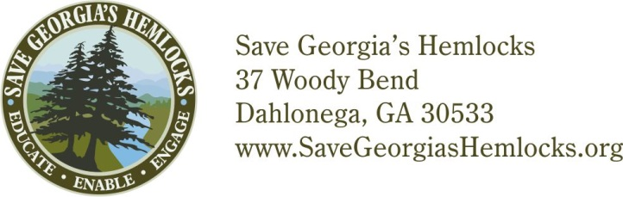

Date

Student Name
Email Address

Re: ___ hours volunteer service with Save Georgia’s Hemlocks

Dear ____________,

Thank you so much for the valuable volunteer service you gave to Save Georgia’s Hemlocks on _____date_____
for _____________kind of service_____________ at ____________location_____________. As we are a volunteer organization, we need and value your support to accomplish our mission of saving the hemlock trees.

Please feel free to give a copy of this letter to your instructor or sponsor to confirm your participation so you can receive credit. He or she is welcome to contact me if further information is needed.

It is wonderful to have young people such as yourself interested in preserving the health of our natural world, and we hope you’ll join us again in the future.

Best wishes for your continued success in school.
Sincerely,

Project Manager Name
Save Georgia’s Hemlocks
Project Manager Phone
Project Manager Email

