Kind of Project and Location
Project Details
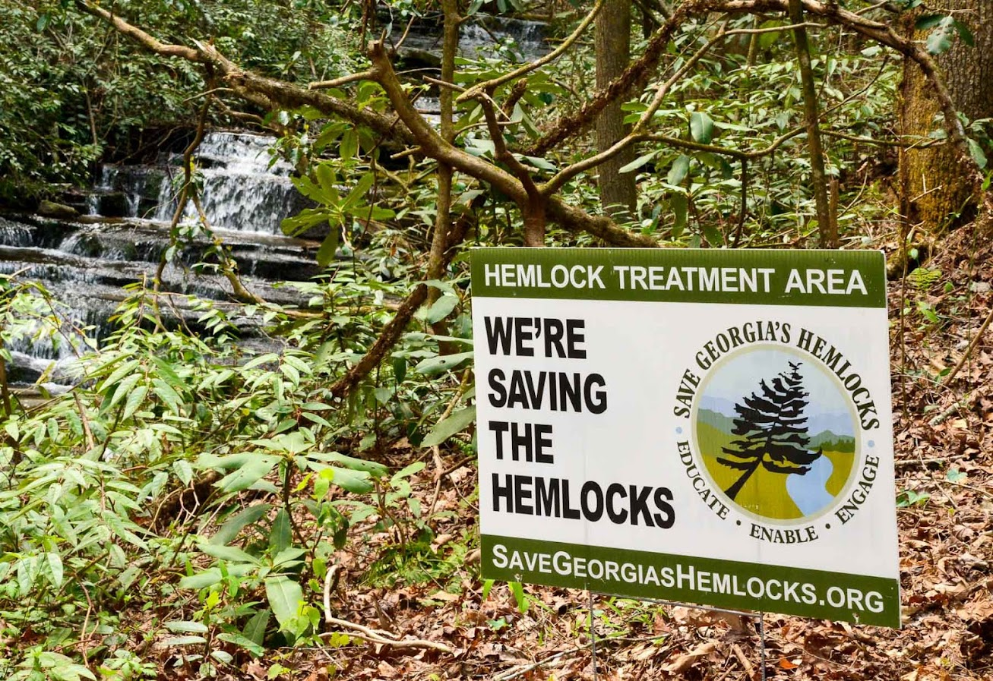
Date | __________________________________
Event | Service event to treat or retreat the hemlocks  in [name of project site] in __________County.  According to prior treatment logs, we expect  to treat or retreat _____ trees.  Photo of project site  or other appropriate image
Notice | As SGH is committed to protecting the health  and safety of our volunteers at all events, we will  be following CDC guidelines regarding the  coronavirus pandemic.  > If you have, or recently have had, a fever or any other symptoms of COVID-19,  please do not sign-up and do seek appropriate medical help.  > Face coverings will not be required but will be available for those wishing to wear them.
Where to Meet | ___________________________________________________________________________  See driving directions and map on following page. Directional signs will be posted.  GPS ____________________________
Schedule | 9:30 a.m. – All SGH volunteers meet. First, you’ll receive a briefing on the condition of the hemlocks, treatment process to be used, and safety reminders. You’ll be organized into small teams including at least one experienced SGH Facilitator per team and receive your equipment and supplies. Then you’ll be directed to your work site and begin treating trees. OR Then we’ll caravan in as few vehicles as possible to the access point for each work site and begin treating trees.  12:30 p.m. – Everyone will break for lunch. After lunch, we’ll resume work.  By 3:00 p.m. (probably sooner) – We’ll stop work, clean the equipment, caravan back to the meeting place, and head for home.
Access | Access to the treatment sites is via Forest Service roads with 2 stream fords. Four-wheel drive is not necessary but high clearance vehicles recommended.
Terrain | The terrain at the work sites is flat in some places and hilly in others but not dangerously steep anywhere. We’ll make sure everyone is assigned to a work site or job assignment where they can be safe and comfortable.
What to Wear | Dress for the weather and the activity, including long pants and long sleeves, gloves and sturdy footgear, and rain gear in case of light rain. Nitrile gloves will be provided for those who will be handling chemicals. On USFS projects, hardhats will also be provided and required to wear for your safety. Two of the sites involve crossing a small stream, so if you have waders or high-top waterproof boots, bring them!
What to Bring | Pack a personal water bottle, sack lunch, and camera if you like. A hiking stick and small day pack to carry things might also come in handy. We’ll provide extra bottled water and snacks.  If you have any serious allergies (like bee stings), bring whatever you need to manage.
Don’t Bring: | This is an environmentally friendly, pack-it-in pack-it-out event, so please don’t bring any glass or Styrofoam items. Also, as much as we love dogs, please don’t bring them.
Registration: | Participants must sign up in advance. Contact ____________________ at [phone number] or [email address]. Please provide both your phone number AND email address.
If you have questions, please call or email before you get to the area as phone service is sketchy there

Map showing location of Project Site

Driving Directions

From ___________________________________________:

From ___________________________________________:

From ___________________________________________:

